Name: Shaik Imtiyaz Aaresh

Id: 1001832768

***Question 1:***

Test case table snapshot:

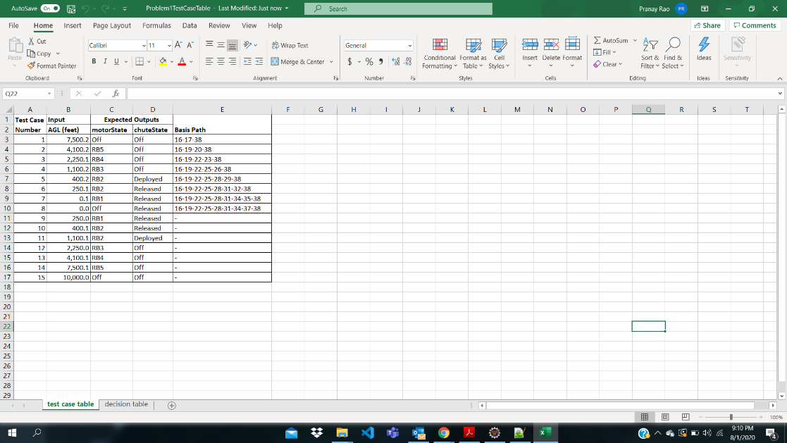

JUnit pass indicator and JaCoCo statement green source line annotations:

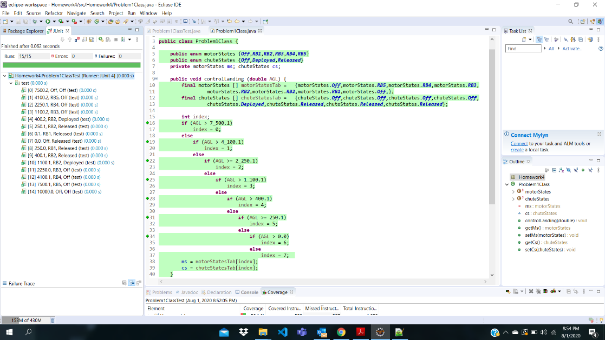

***Question 2:***

Test case table snapshot:

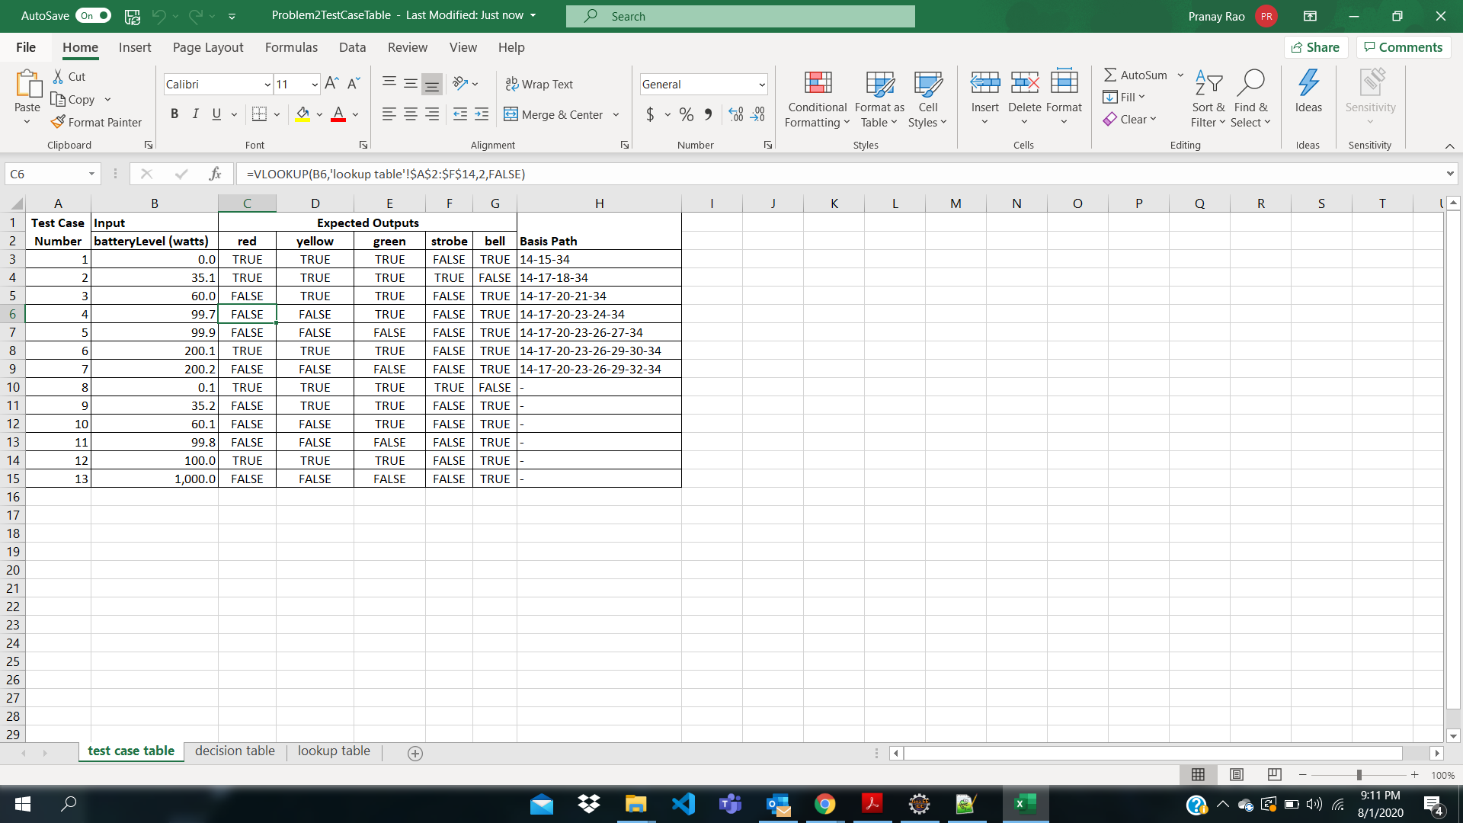

JUnit pass indicator and JaCoCo statement green source line annotations:

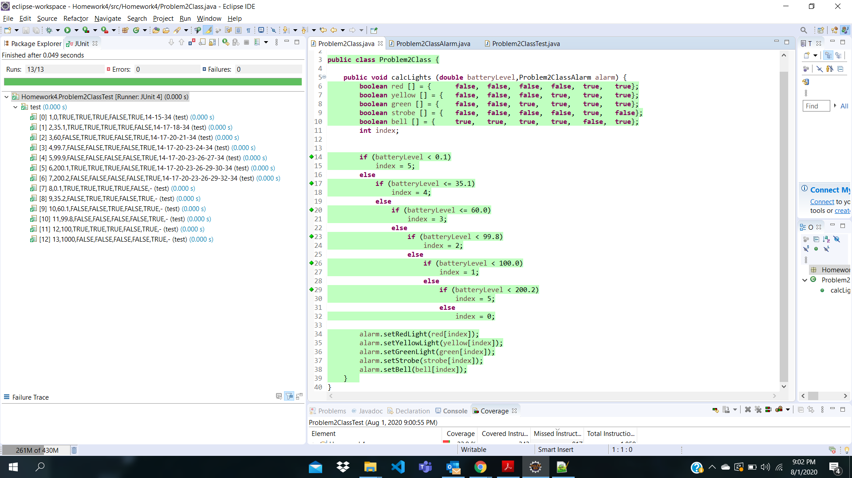

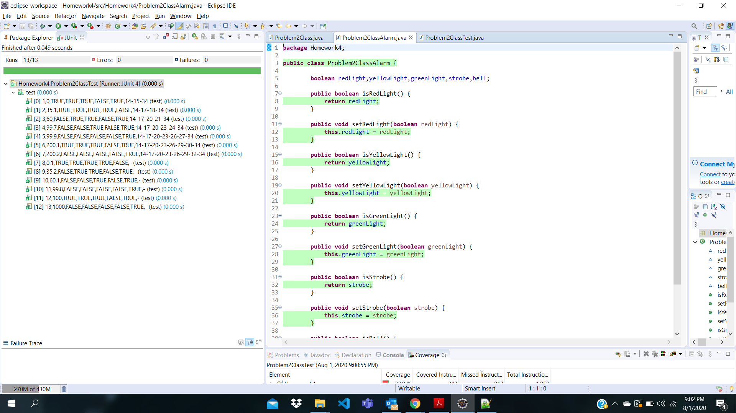

***Question 3:***

Test case table snapshot: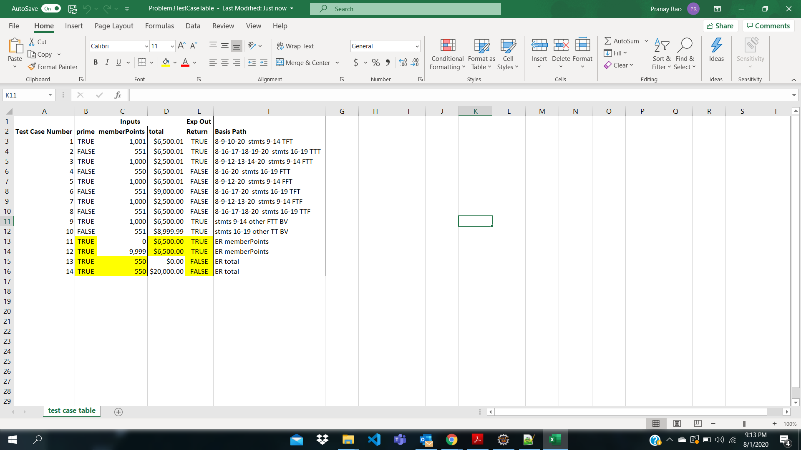

JUnit pass indicator and JaCoCo statement green source line annotations:

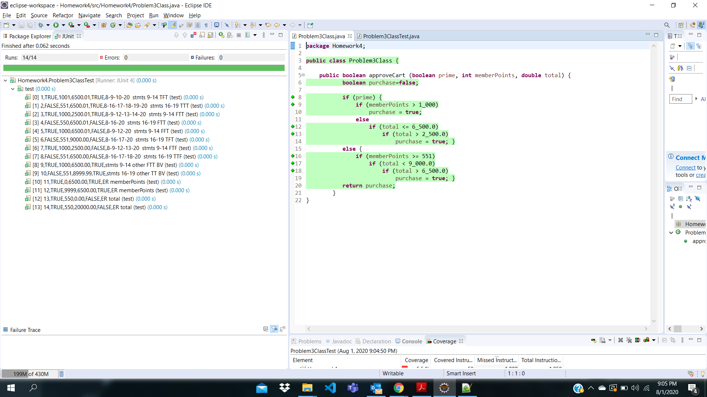

***Question 4:***

Test case table snapshot:

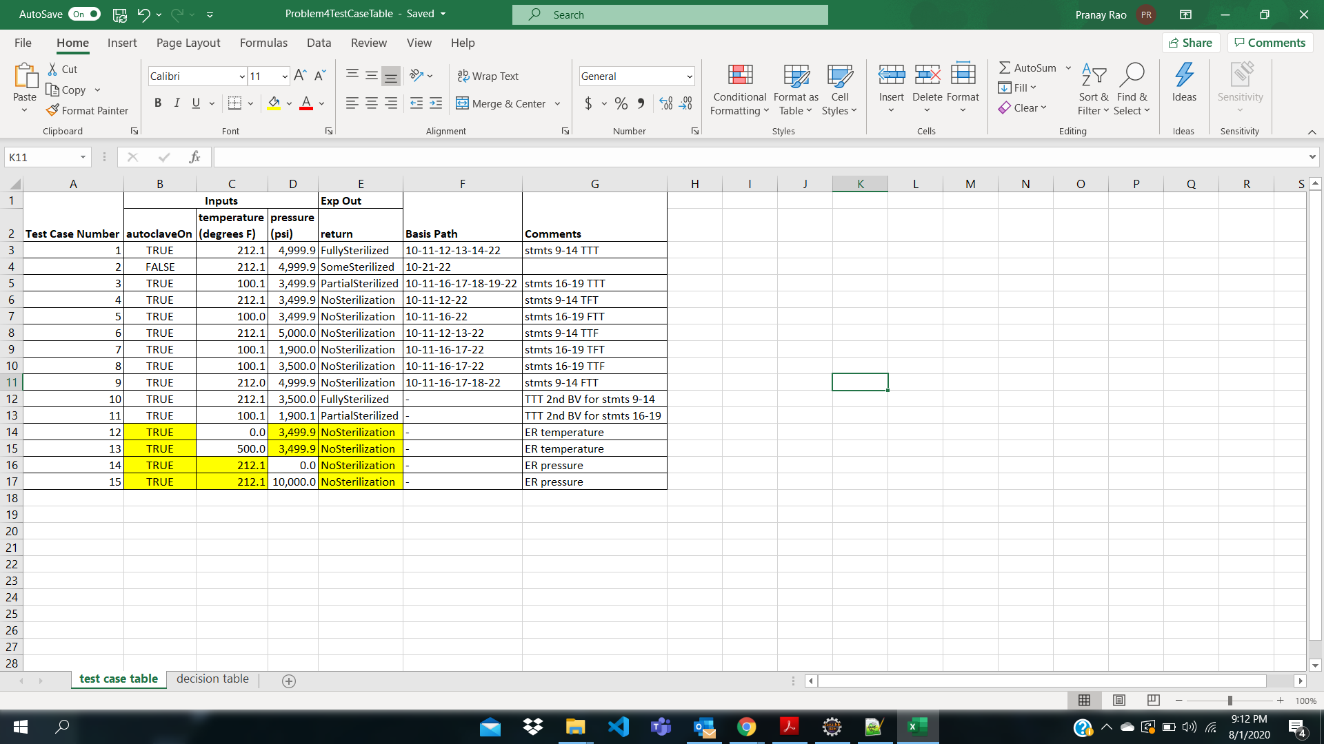

JUnit pass indicator and JaCoCo statement green source line annotations:

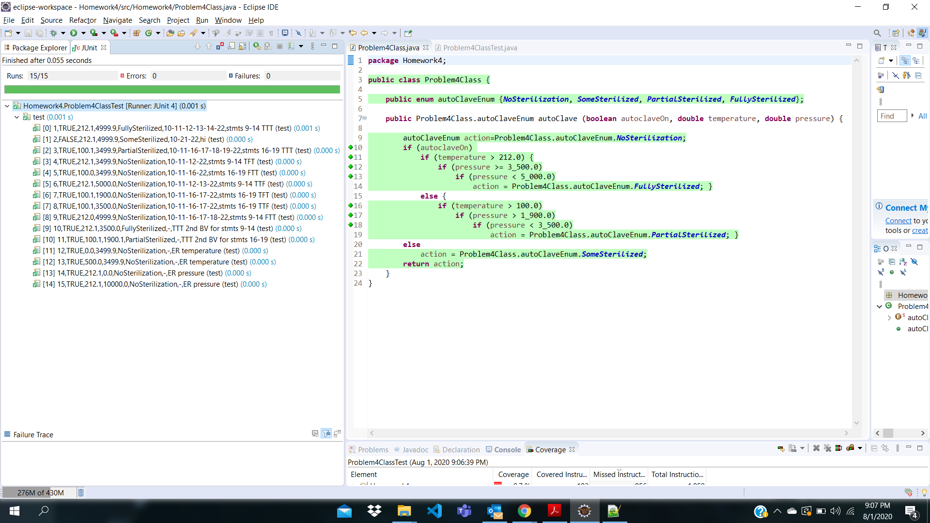

***Question 5:***

Test case table snapshot:

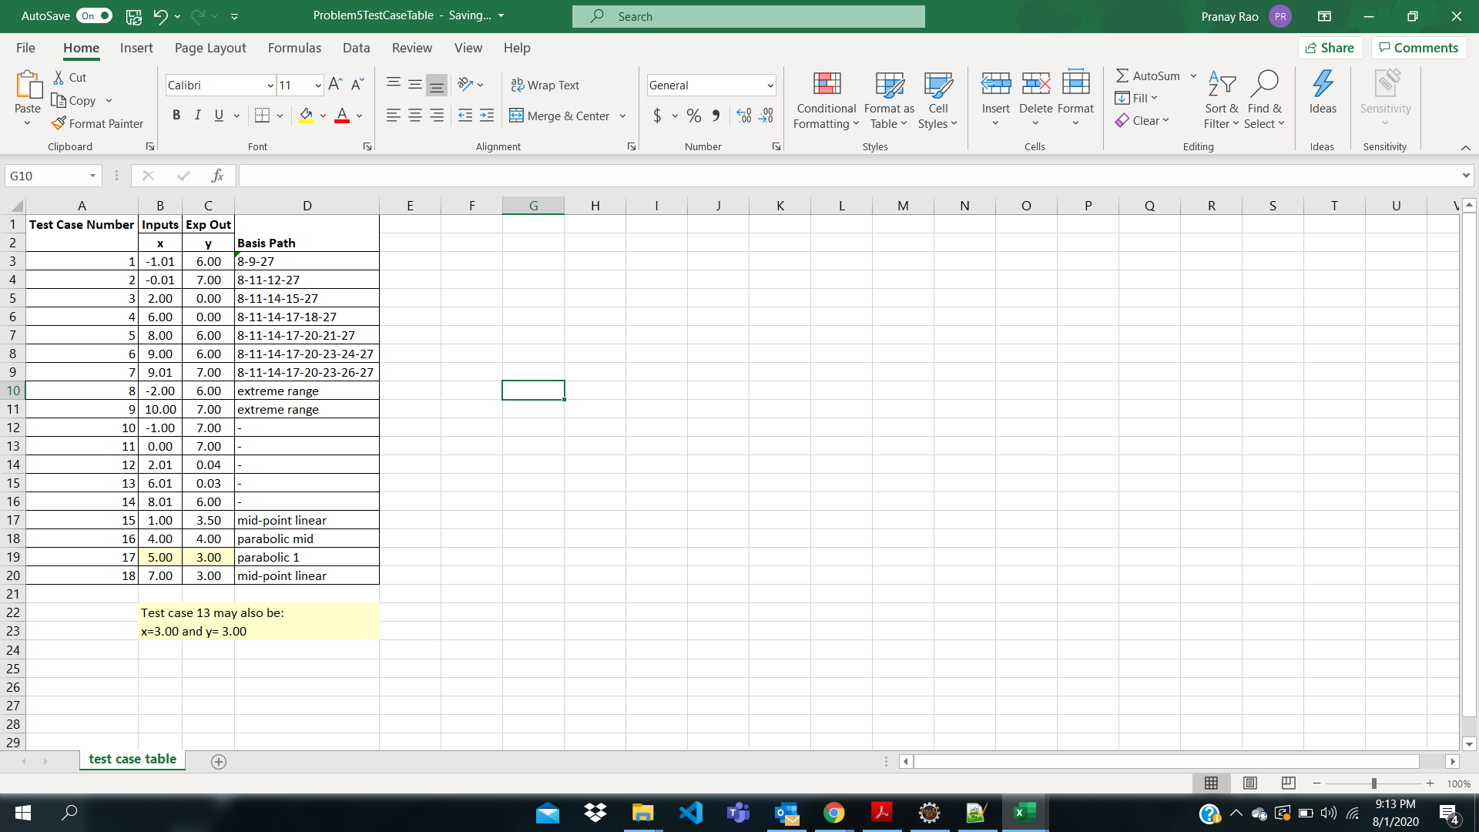

JUnit pass indicator and JaCoCo statement green source line annotations:

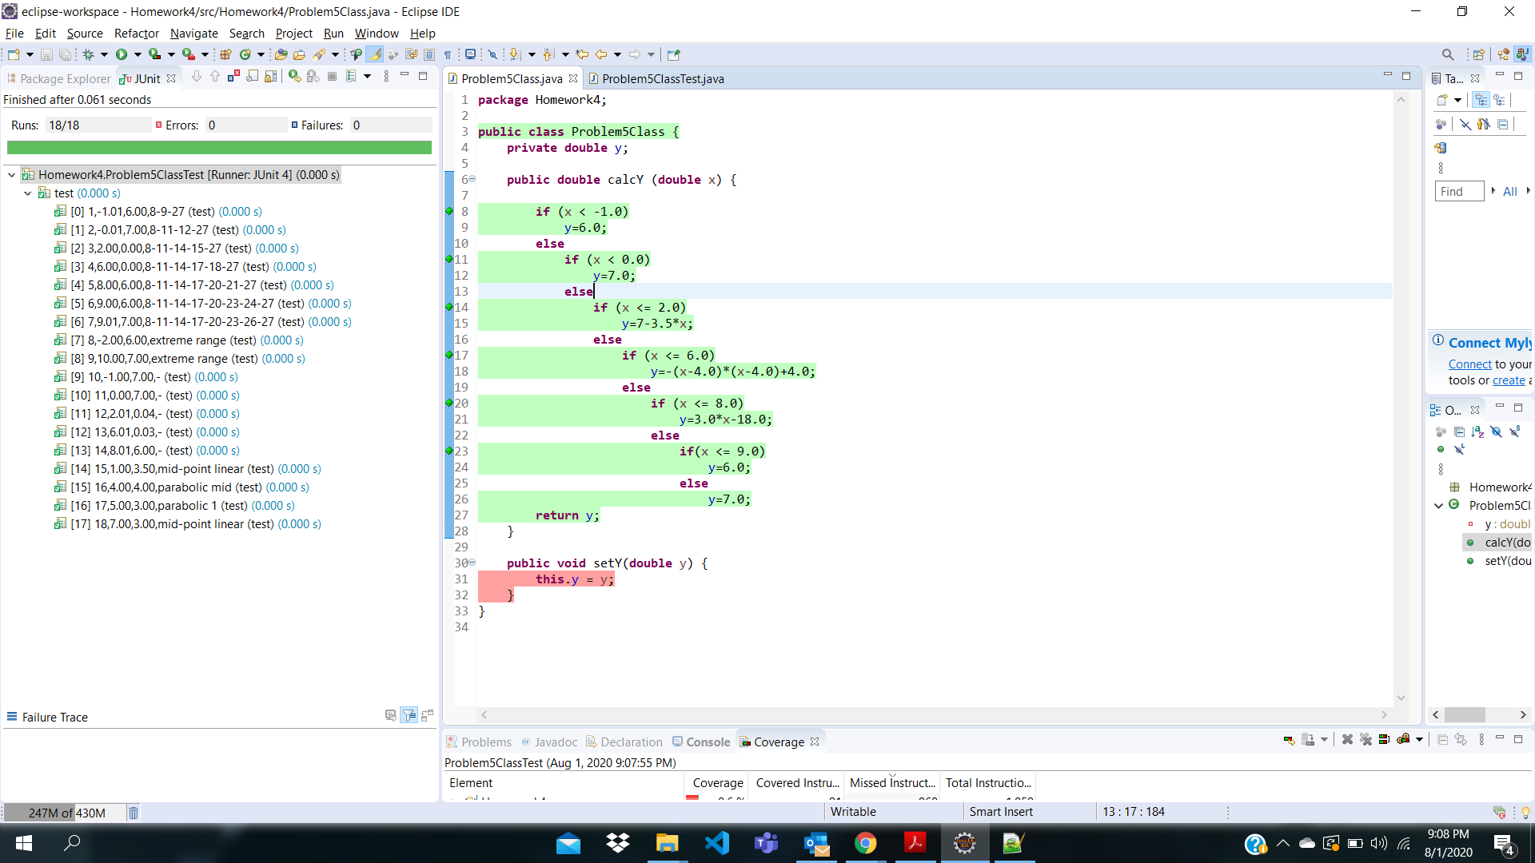

***Question 6:***

Logical expression for each of values produced:

Value 1: abcd’

MC/DC: TTTF, FTTF, TFTF, TTFF, TTTT

Value 2: abcd

MC/DC: TTTT, TFFF, FTFF, FFTF, FFFT

Value 3: abc’ + ab’c + ab’c’

MC/DC: FTFF,TTFF,TFFF,TTTF

Value 4: a’bc’+a’b’c’

MC/DC: TFFF,FTFF,FFFF

Value 5: a’b’c

MC/DC: FFTF, TFTF, FTTF, FFFF

***Question 2:***

Logical expression for Value 1: abcd’

Range of possible erroneous values: 2-3(2,3)

Logical expression for Value 2: abcd

Range of possible erroneous values: 3-5 (3,4,5)

Logical expression for Value 3: abc’ + ab’c + ab’c’

Range of possible erroneous values: 4

Logical expression for Value 4: a’bc’+a’b’c’

Range of possible erroneous values: 5

Logical expression for Value 5: a’b’c

Range of possible erroneous values: 3-4(3,5)